**Cyclistic Bike-Share Analysis Report**

Analysis report by Keiran Seth V. Castrodes  
This case study is for the partial fulfillment of the Google Data Analytics Professional Certificate.

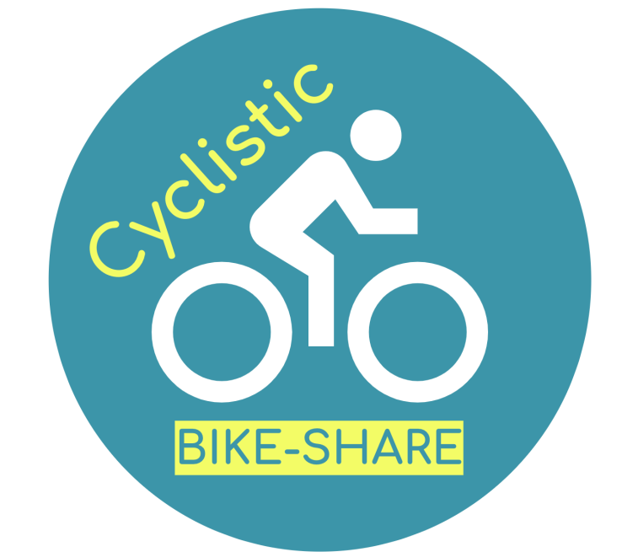

# **Introduction**

Cyclistic is a bike-share company that started in 2016, with a total of 5,824 bicycles which are geotracked and are accessible within 692 stations throughout Chicago. A Cyclistic customer has three bicycle options, which are: the classic bicycle, the electric bicycle, and the electric scooter.

To maximize their consumer base, the main strategy used by Cyclistic is in presenting flexible pricing options. These pricing options include single-ride passes, full-day passes, and annual memberships. In the rest of this report, the customers who purchase single-ride passes and full-day passes are called *casual riders* or *casuals*, and the customers who purchase annual memberships are called *members*.

Since the finance team concluded that annual members are much more profitable to the company compared to casuals, the marketing team decided that maximizing annual memberships will lead to future growth. Thus, the marketing efforts and strategies will be aimed at converting casuals into members.

## **Problem Statement for the Analytics Team**

To help the marketing team, we, the analytics team, must answer the question, which serves as this report’s main problem statement:

**How do annual members and casual riders use Cyclistic bikes differently?**

# **Body**

## **Data Preparation**

Cyclistic’s entire 2024 bike trip dataset spanning 12 months is compiled and transformed using Power Query. To summarize,

* the fields are converted into their appropriate data types,
* fields such as day_of_week_number, month_number, quarter_of_year, and ride_duration are manually added, and
* delete records with empty/null cells.

To see more detailed information about the data preparation process, [see the documentation of data preparation](https://github.com/toeireishuman/cyclistic-bike-share-analysis/blob/main/data_preparation.md).

## **Analysis**

This report will divide the analysis portion into two parts. The first part will cover the differences of rider count in terms of membership type and bicycle options, and the second part will observe the trends in both ride count and ride duration. Note that the second part will also observe how these trends differ between casual riders and members.

### **Differences in Membership and Bicycle Types**

#### **What is the distribution and proportion of riders in terms of membership type?**

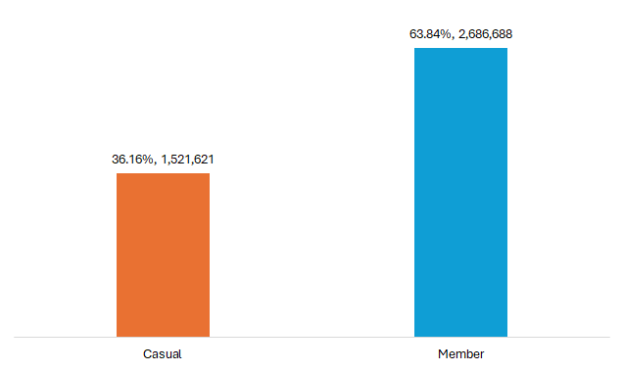

Figure 1. Distribution and proportion of riders by membership type.

It is already established by the marketing and finance team that there are more annual members than casual members. To verify, there are indeed **almost twice as many members as casuals**, as reflected in the 2024 Cyclistic customer base shown above.

To be more specific:

* 1,521,621 riders, around 36.16% of all riders in 2024, are only casuals, and
* 2,728,147 riders, around 63.84% of all riders in 2024, are members.

#### **What is the distribution and proportion of riders in terms of bicycle type?**

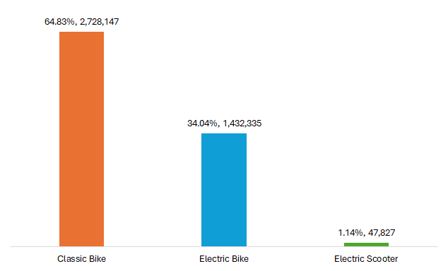

Figure 2. Distribution and proportion of riders by bicycle type

Looking at bicycle types, we see that **more than half of the riders use classic bikes, around a third use electric scooters, and around 1% use electric scooters**.

To be more specific:

* 2,728,147 riders, around 64.83% of all riders in 2024, use classic bikes,
* 1,432,335 riders, around 34.04% of all riders in 2024, use electric bikes, and
* 47,827 riders, around 1.14% of all riders in 2024, use electric scooters.

#### **How does the distribution and proportion of bicycle types differ between members and casual riders?**

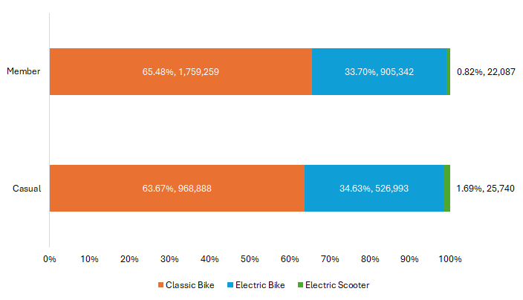

Figure 3. Distribution and proportion of riders by membership and bicycle types.

The two insights established in the previous two questions are also reflected in both membership type and bicycle type, which are:

* There are more members than casuals, and
* The order of bicycle type frequency of use: Classic bike (around 64%), electric bike (around 34%), and electric scooter (around 1%).

However, observe that **among members and casuals who rode electric scooters, there are more casuals than members***.*

#### **What is the total ride duration? The average ride duration? The maximum ride duration?**



Figure 4. The total, average, and maximum ride durations in 2024.

* There is a total ride duration of **1,168,374 million hours, 21 minutes, and 41 seconds in 2024**.
* The average ride duration in 2024 is **16 minutes and 39 seconds**.
* The longest ride duration in 2024 is **25 hours, 9 minutes, and 22 seconds**.

#### **What are the total and average ride durations in terms of membership type?**

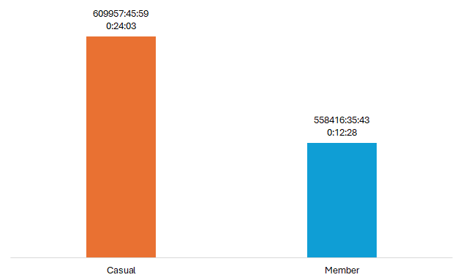

Figure 5. The average ride duration by membership type, labeled with total average ride duration.

* For casual riders, the average ride duration in 2024 is **24 minutes and 3 seconds**, and the total ride duration in 2024 is **609,957 hours, 45 minutes, and 59 seconds**.
* For members, the average ride duration in 2024 is **12 minutes and 28 seconds**, and the total ride duration in 2024 is **558,416 hours, 35 minutes, and 43 seconds**.

Note that while there are almost half as less casuals as there are members, **the total ride and average ride duration are dominated by casual riders**.

#### **What are the total and average durations in terms of bicycle type?**

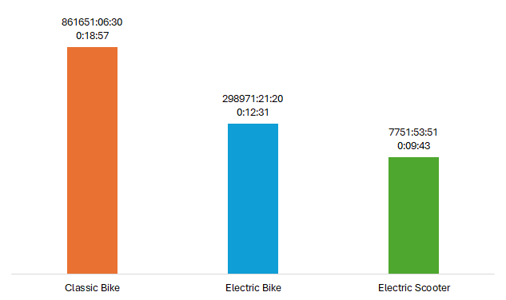

Figure 6. The average ride duration by bicycle type, labeled with total average ride duration.

* For classic bikes, the average ride duration is **18 minutes and 57 seconds**, and the total ride duration is **861,651 hours, 6 minutes, and 30 seconds**.
* For electric bikes, the average ride duration is **12 minutes and 31 seconds**, and the total ride duration is **298,971 hours, 21 minutes, and 20 seconds**.
* For electric scooters, the average ride duration is **9 minutes and 43 seconds**, and the total ride duration is **7,751 hours, 53 minutes, and 51 seconds**.

We now know that the order of both the average ride duration and the total ride duration is identical to the order of the frequency of use.

#### **What are the total and average durations in terms of bicycle type and membership type?**

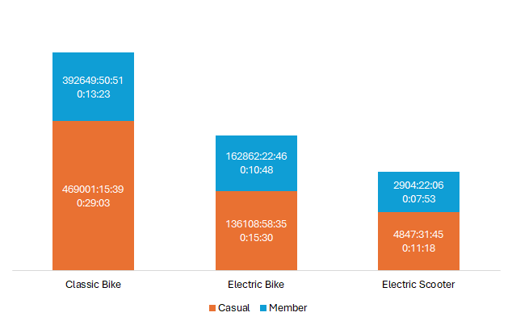

Figure 7. The average ride duration by bicycle type and membership type, labeled with total ride duration.

We now know that the longer average and total ride durations of casual riders against members are also reflected across all bicycle types.

### **Trends in Rider Count and Ride Duration**

#### **By Quarter**

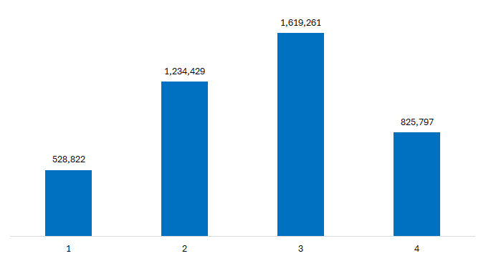

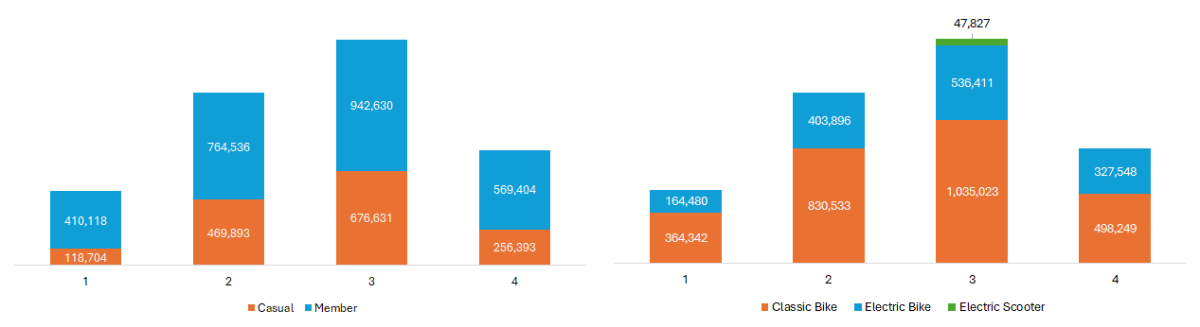Figure 8. Quarterly rider count in 2024.

Figure 9. Quarterly Rider Count for 2024 by Membership and Bicycle Type.

Let us now observe the trends of the rider count quarterly, whilst keeping in mind the differences in terms of membership type and bicycle type. We find the following insights:

* The rider count peaks in quarters 2 and 3, exceeding one million bike rides, with Quarter 4 being only around 200,000 users short.
* Across all quarters in the year 2024, members dominate the ride count, all of which are at least 100% more than casual riders.
* Across all quarters in the year 2024, classic bikes dominate the ride count, all of which are at least 100% more than both electric bikes and electric scooters.
* Electric scooters are only used in the third quarter, not even exceeding 50,000 users. We will see later which months they are used.

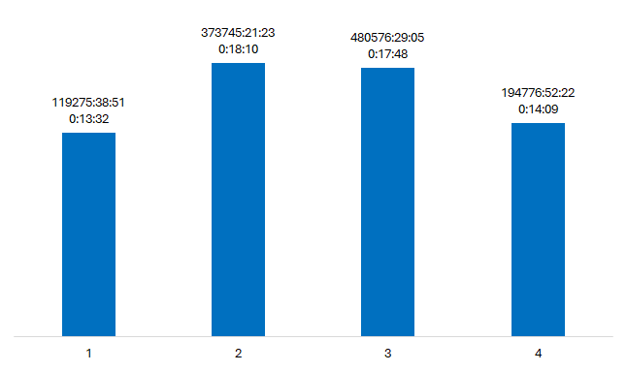

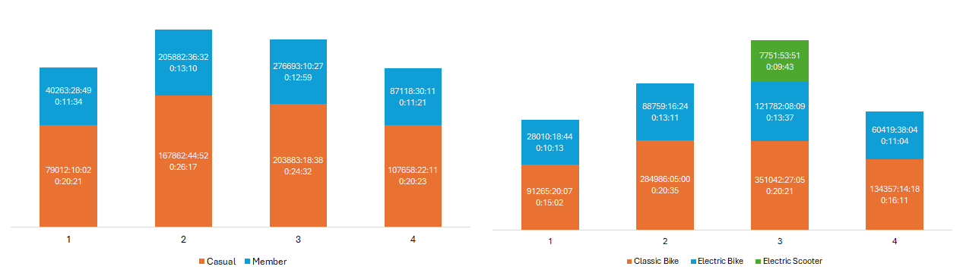Figure 10. Quarterly average ride duration, labeled with total ride duration.

Figure 11. Quarterly average ride duration by Membership and Bicycle Type, labeled with total ride duration.

After rider count, let us now observe the trends in the average ride duration quarterly, whilst keeping in mind the differences in terms of membership type and bicycle type. We find the following insights:

* In terms of average ride duration, Quarters 2 and 3 are at least 2 minutes longer than Quarters 1 and 4.
* Across all quarters in the year 2024, casual riders bike longer on average than members. In fact, casual riders bike around twice as long as members.
* Across all quarters in the year 2024, classic bikes accrued on average higher ride durations compared to electric bikes and electric scooters.
* In Quarter 3, electric scooters are only used in at most 10 minutes, on average.

#### **By Month**



Figure 13. Monthly rider count in 2024.

Figure 12. Monthly rider count by membership and bicycle type.

Let us now observe the trends of the rider count quarterly, whilst keeping in mind the differences in terms of membership type and bicycle type. We find the following insights:

* The rider count peaks from May to October, exceeding 400,000 riders monthly. Note that April is only at least 100,000 riders short.
* Across all months in the year 2024, members dominate the ride count, all of which are at least 100% more than casual riders.
* Across all months in the year 2024, classic bikes dominate the ride count, all of which are at least 100% more than both electric bikes and electric scooters.
* The overwhelming majority of riders who used electric scooters are in September.



Figure 14. Monthly ride duration in 2024.

Figure 15. Monthly ride duration by membership and bicycle type.

After ride count, let us now observe the trends in the average ride duration monthly, whilst keeping in mind the differences in terms of membership type and bicycle type. We find the following insights:

* The average ride duration peaks from April to September, exceeding ride duration of 16 minutes monthly.
* Across all months in the year 2024, casual riders bike longer on average than members.
* Across all quarters in the year 2024, classic bikes accrued on average higher ride durations compared to electric bikes and electric scooters.
* Since the majority of riders who use electric scooters are in September, their average ride duration will most likely not to exceed 10 minutes.

#### **Within a week**



Figure 16. Average rider count within a typical week in 2024.



Figure 17. Average rider count within a typical week by membership and bicycle type.

Let us now observe the trends of the average rider count by day of week, whilst keeping in mind the differences in terms of membership type and bicycle type. We find the following insights:

* The average rider count has sudden peaks on Wednesday and Saturday.
  + Looking at membership type, we find that the Wednesday peak is caused by the increase in members during the weekdays.
  + Looking at membership type, we find that the Saturday peak is caused by the increase in casual riders during the weekends.
* Across all days of the week, members dominate the average ride count.
* Across all days of the week, classic bikes dominate the average ride count.



Figure 18. Average ride duration within typical a week in 2024.



Figure 19. Average ride duration within a typical week by membership and bicycle type.

Let us now observe the trends of the average duration by day of week, whilst keeping in mind the differences in terms of membership type and bicycle type. We find the following insights:

* The average rider count has sudden peaks on Saturday and Sunday.
  + Looking at membership type, we find that the sudden peak on the weekend days is caused by the increase in casual riders during the weekends.
* Across all days of the week, casual riders dominate the average ride duration.
* Across all days of the week, classic bikes dominate the average ride duration.

# **Conclusion**

In this section, let us gather and summarize key insights.

1. There as more members (at least twice as many as) than casual riders.
2. Classic bikes are used by more than half of the rides in 2024. Electric bikes cover one-third. Electric scooters are rarely used.
3. Across membership types, insight 2 still holds. However, note that among riders who used electric scooters, there are more casual riders than members.
4. The average ride duration is 16 minutes and 39 seconds. The total ride duration exceeds 1,000,000 hours.
5. On average, casual riders bike twice as long as members. They also dominate the total ride duration.
6. Across all membership types, insight 2 still holds, and casual riders bike twice as long as members.
7. Quarters 2 and 3 observe peaks in ride count and average ride duration.
   * + Across all quarters, there are at least 100% more members than casuals, but casuals still ride twice as long as members.
     + Across all quarters, insight 2 still holds.
8. Ride counts are observed to peak from May to October, while ride durations are observed to peak from May to August.
   * + - Across all months, there are at least 100% more members than casuals, but casuals still ride longer than members.
       - Across all months, except for August, insight 2 still holds.
9. Average ride counts are observed to peak on Wednesday and Saturday, while average ride durations are observed to peak on the weekends (Saturday and Sunday).
   * + - Across all days of the week, there are more members on average than casuals, but casuals still ride twice as long as members.
       - Across all days of the week, insight 2 still holds.

Now that we have all these insights, let us now select the ones which are relevent to the problem statement.

**How do annual members and casual riders use Cyclistic bikes differently?**

* Annual members dominate the ride count across bicycle types, and across all quarters, months, and in any day of the week.
* Casual riders dominate the average ride duration across bicycle types, and across all quarters, months, and on any day of the week.
* The average ride duration of annual members is more or less within 12 to 14 minutes across all quarters, months, and on any day of the week.
* The average ride duration of casual riders is more or less within 14 to 28 minutes across all quarters, months, and on any day of the week.
* In the use of electric scooters in August and September, there are more casual riders than annual members.

## **Recommendations**

After finding out that casual riders often bike twice as long as annual members, the analytics team mainly recommends more research on why this is so. Although we can formulate the following hypotheses:

* Casual riders use the bike-share service for leisurely bike rides or for cycling exercise, especially on the weekends.
* Annual members use the bike-share service for utility and transportation/commute, especially on the weekends.

***The analytics team cannot assert the nature of these hypotheses from the differences of the ride duration between casual riders and annual members alone, unless we have more comprehensive data in the form of brief surveys and questionnaires to our entire consumer base.*** Hopefully, with more comprehensive data for next year, the analytics team can uncover deeper insights.

The main, but tentative, recommendation from the analytics team is:

**Create annual pricing plans tailored for prospective bikers and scooters who ride either for leisure and scenery rides, or for exercise, such as long-distance cycling.**

Since the analytics team also looked at quarterly and monthly trends of the ride duration and average ride count, another recommendation by the analytics is:

**Increase or emphasize advertising for the months May to October, or quarters 2 and 3, using tailored pricing plans for leisure, recreation, or exercise to casual riders.**

# **Appendix**

See the [preliminary analysis report](https://github.com/toeireishuman/cyclistic-bike-share-analysis/blob/main/preliminary/preliminary_analysis.md) for further insights not included in the main analysis report.

See the [project repository](https://github.com/toeireishuman/cyclistic-bike-share-analysis) to view the case study in its entirety.